Bruce’s Story Study Guide
Teacher Key

Historical Context

(May be useful for pre-reading/ pre-watching of story to provide context, or as post-reading/ post-watching to clarify events in the story:)

In the 1920’s, Germany, Japan, and Italy were three countries that were struggling: people were poor and hungry, and things were not getting better. By the 1930’s, three rulers had come to power in these three countries: Adolph Hitler in Germany, Emperor Hirohito in Japan, and Benito Mussolini in Italy. All three leaders built up their countries’ military and took aggressive action to invade and conquer other countries in order to help their own country gain power and prosperity. In 1940, these three countries signed an alliance together and joined forces to continue to invade and conquer even more countries. Because this was going on mostly in Europe – which is on the other side of the globe – the United States did not get involved because US leaders at the time felt it was not their concern. The was was far enough away that the United States should be safe.

On December 7th, 1942 a Navy base in Hawaii was attacked by Japanese fighter jets. That meant that the United States now had to get involved in the war. Because it was the Japanese who had attacked Pearl Harbor, and the Japanese were allied with Germany and Italy, the United States was now at was with Japan, Germany, and Italy. At the time, there were thousands of different types of people living in the United States – including thousands of people who were Japanese. Many of them had lived in the United States for their most of their lives. Many had been born here, and had never been to Japan. The United States Government decided that, because Japanese people from Japan had attacked the United States, that everyone who was descended from Japanese people could not be trusted. The Government issued Executive Order 9066, which ordered all Japanese and people of Japanese ancestry to pack up their lives and move into fenced into incarceration prison-camps that they were not allowed to leave for any reason, including school or work. Very soon after this decision was made, many of the “heads of households” were taken away and held in jails by the Government for questioning.

Listen to the first 55 seconds of this radio broadcast:
https://www.youtube.com/watch?v=ZbKLkJymyQE
What information do you know from this recording?

Now, look at this poster:
http://digital.auraria.edu/AA00004665/00001
What information do you learn from this poster?

Post-Reading/ Post-Watching Story:

Now that you have heard Bruce’s story, piece together the historical events that triggered each of his experiences. What was his family listening to around the radio after his mother brought him home from playing baseball? What event had occurred that was being reported on? Why did his father never return from work?

Reading/ Literary/Comprehension

Why do you think the blinds were kept closed on the train into the prison-camp? Why weren’t the passengers allowed to see out the window?

The passengers were not allowed to see out so that they would not know where they were, so that would not try to escape, and so that they would feel helpless and be more compliant and cooperative.

What do the people in the prison-camp do in order to try and cope with their new situation? What positive changes do they make? What actions do they take?
What does it tell you about the people in the prison-camp that they acted to improve their circumstances?

Improve the food served, play games, set up sports games, dances, outdoor movie screenings, schools and the fair. This indicates that the people were resilient and rose to the task of doing the best they could with what was available to them.

How does Bruce’s perspective on being Japanese change through the story? Why does he feel the way he does? Do you understand why he would feel this way? Why or why not?

Bruce begins to feel a sense of self-loathing for being Japanese. He is heavily influenced by the way he sees Japanese people being treated and regarded by those in power. He begins to feel the pressure of isolation, of being targeted by his society and government, and of seeing his parents, brother, and the other adults in her life dealing with their own stress and anxiety.

Bruce’s parents, and many others in the prison-camp, are upset by Questions 27 and 28 in the Questionnaire they are required to fill out. Examine the text of those Questions:

#27: “Are you willing to serve in the armed forces of the United States on combat duty, wherever ordered?”

#28: “Will you swear unqualified allegiance to the United States of America and faithfully defend the United States from any and all attacks by foreign and domestic forces, and forswear any form of allegiance or disobedience to the Japanese Emperor, or any other foreign government, power, or organization.”

Why are these questions problematic? Why do Bruce’s parents struggle with how to answer them?

#27 asks individuals to fight and be possibly wounded or killed for a country that has incarcerated them.
#28 is a bit of a catch-22. Answering “YES” to this question might imply that the individual had at one point previously been loyal to Japan and the Japanese Emperor, when this was very often not the case, since many in the prison-camps had been born in the United States and never lived in Japan. This could be incriminating.

Culture Shock: the feeling of confusion, or of feeling out of place experienced by someone who is suddenly in an unfamiliar culture, way of life, or set of attitudes.
When does Bruce experience culture shock during the story?
When he is suddenly living among only other Japanese people. When he suddenly leaves the prison-camps and is thrust back into the “real” world.

Symbolism
Definition: the use of symbols to represent ideas.

For example: A bridge is a structure that physically joins two places, and makes it possible for people
to get from one place to another, and to visit each other. What might the bridge be a symbol for?
Sharing, Friendship, Trust, Tolerance

In the text:
What is the recurrent symbol used throughout the story? What do they symbolize?
Bruce’s shoes. They symbolize Bruce’s growth, his shame, his anger, his sense of constantly needing to settle for second-best, his sense that nothing is truly his, his sense of being trapped, cramped into a space that is too small and uncomfortable. At the end, his new shoes symbolize a fresh start, something to be proud of and look forward to.

Bruce spends his time pacing around the perimeter of the prison-camp and throwing rocks at the fence. What does this behavior symbolize?
The feeling of smallness, the feeling that no matter what you do it doesn’t matter, the feeling of being trapped by something enormous that you cannot get to the other side of.

In the school at the prison-camp, the teacher invites him to sit under the flag. The description of this image in the text reads “The red, white and blue of the flag looked like a cartoon against the dusty walls and floor.” What might the flag symbolize at this moment in the story to Bruce? Why does it look like a cartoon to him?
The flag would be the American Flag. It symbolizes the ideals of the country: freedom, liberty, protection, and justice. The fact that Bruce would be sitting under the flag of the country who has denied him these ideals symbolizes the oppression and persecution that Bruce is feeling. It looks like a cartoon because, in his mind, the flag is a joke.

Connect to the Text

The Japanese population was forced to leave their homes, and carry only one suitcase with them. What would you take? Make a list of the items you would bring with you – clothing, toiletries, personal items. Limit your list to fifteen items total. Remember you only have one suitcase!

What would you miss if you suddenly had to leave everything you’ve ever known? What activities would you miss? What food would you miss? What people would you miss?

When have you felt like your life was completely out of control? How did this make you feel? Why? What were actions you took to make yourself feel better or “normal” again?

Have you ever experienced being separated or excluded in a way that you felt was unfair? Describe this experience. How did it make you feel?

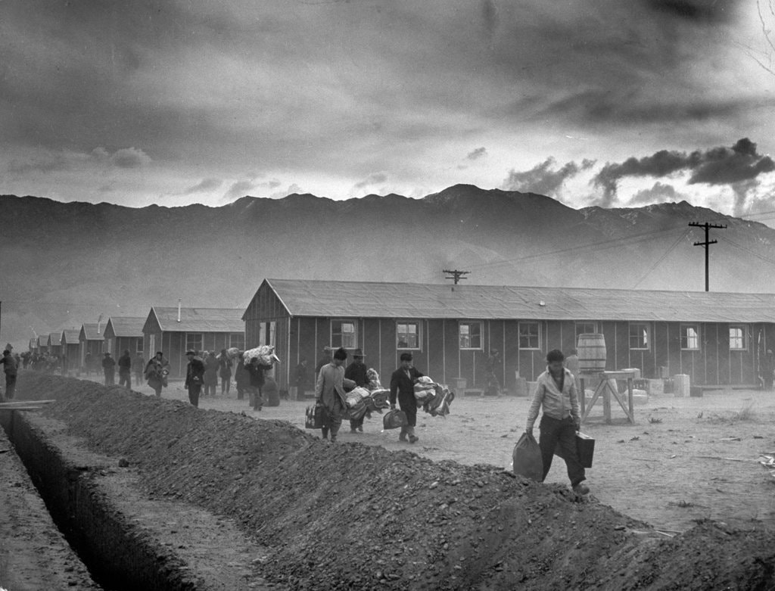
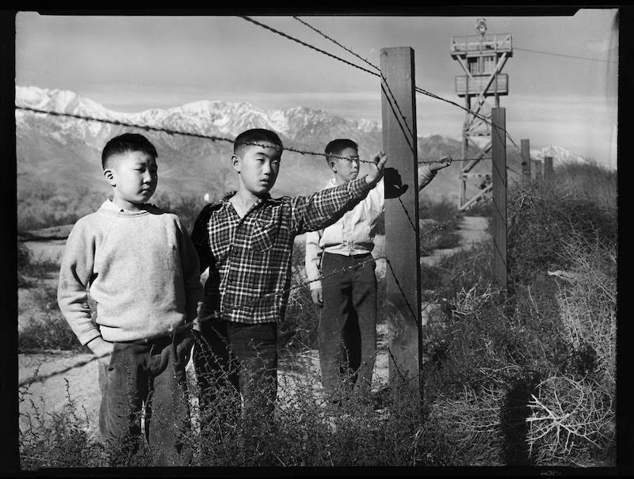
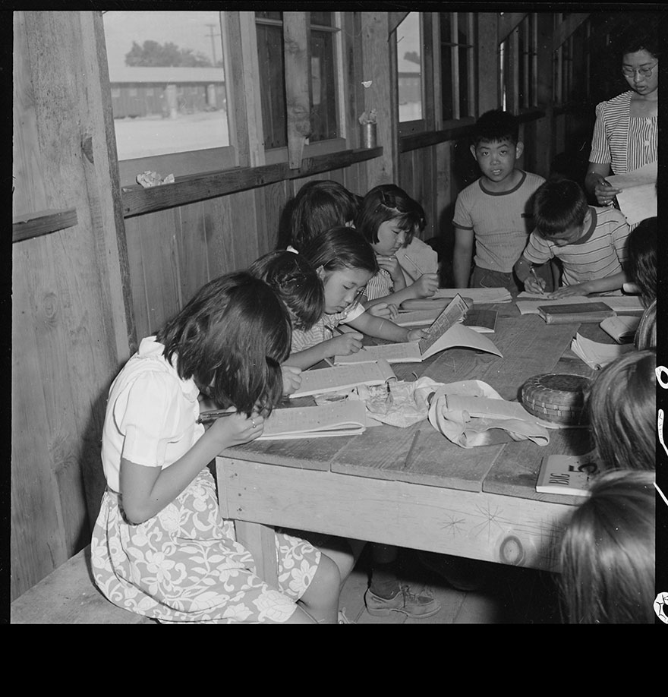
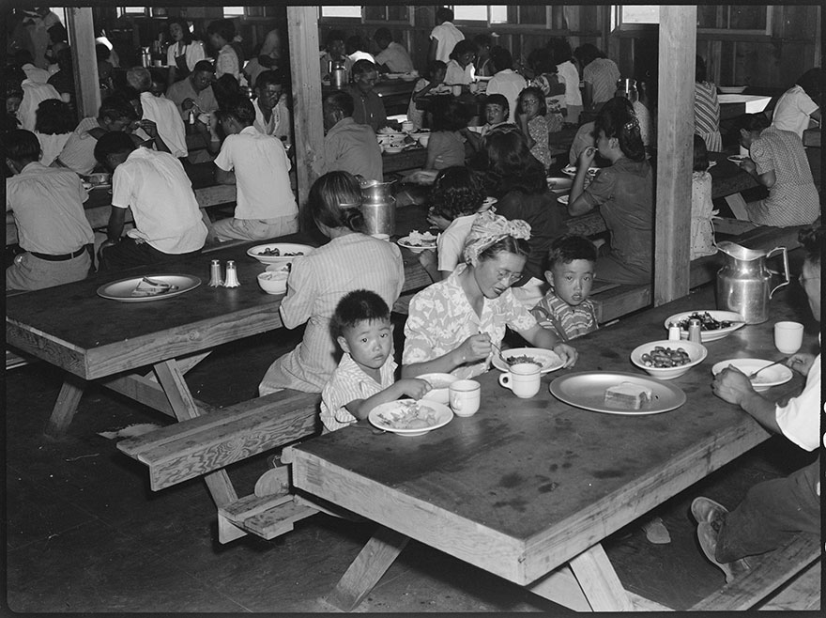
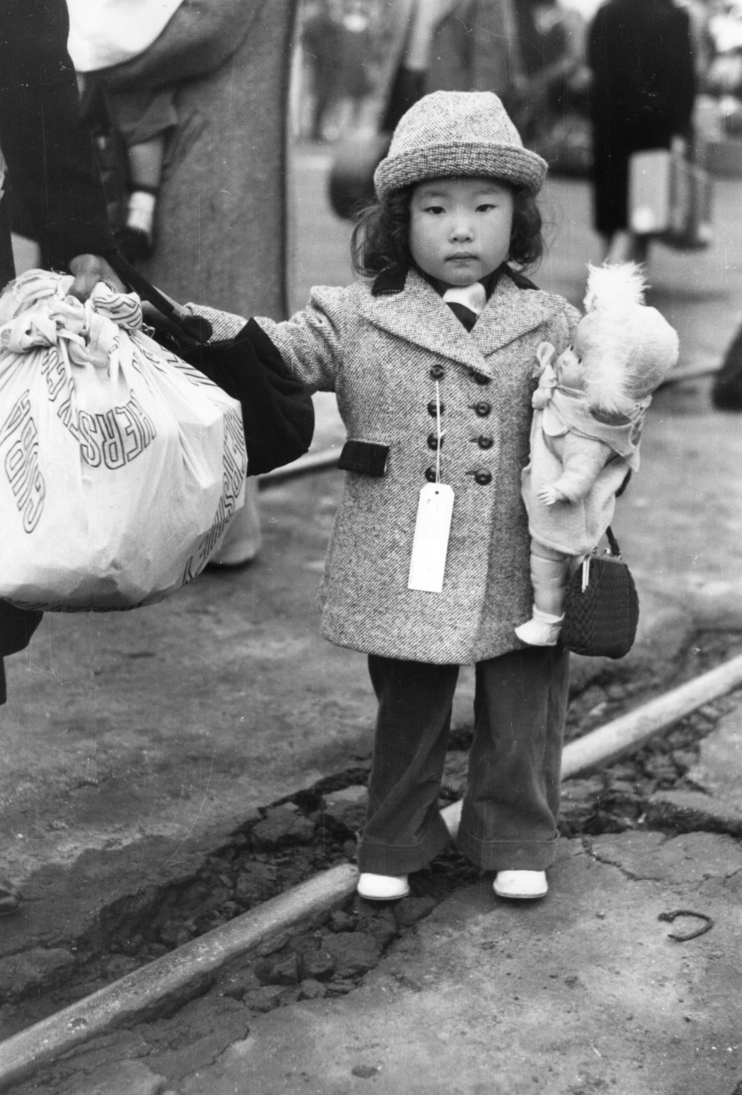
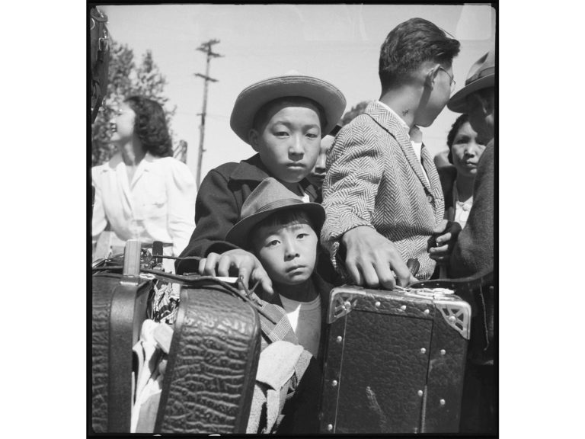
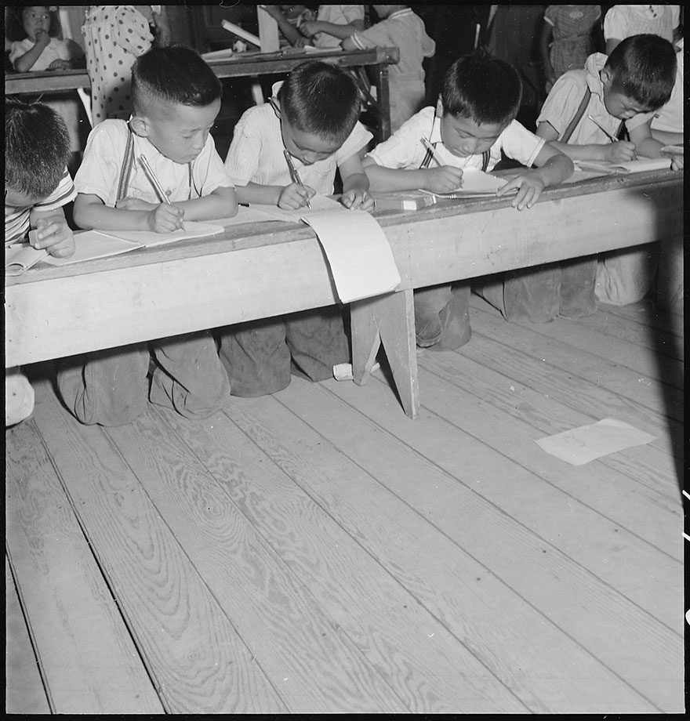
1 & 2) Look at how small the suitcases and bundles are. Imagine packing up everything you own into something so small.
3) Imagine arriving here after two or three days of travel. How does this environment make you feel?
4) Imagine eating every meal in a room like this. What does it sound like? Smell like? Is this a comfortable place to eat?
5 & 6) How do these pictures of school compare to your school?
1
2
3
4
5
6
7
7) How do you think these boys are feeling? How would you feel? Why?

