Ayako’s Story Study Guide
Teacher Key

Historical Context
(May be useful for pre-reading/ pre-watching of story to provide context, or as post-reading/ post-watching to clarify events in the story:)

In the 1920’s, Germany, Japan, and Italy were three countries that were struggling: people were poor and hungry, and things were not getting better. By the 1930’s, three rulers had come to power in these three countries: Adolph Hitler in Germany, Emperor Hirohito in Japan, and Benito Mussolini in Italy. All three leaders built up their countries’ military and took aggressive action to invade and conquer other countries in order to help their own country gain power and prosperity. In 1940, these three countries signed an alliance together and joined forces to continue to invade and conquer even more countries. Because this was going on mostly in Europe – which is on the other side of the globe – the United States did not get involved because US leaders at the time felt it was not their concern – that the war was far enough away and the United States should be safe.

On December 7th, 1942 a US Navy base in Hawaii was attacked by Japanese fighter jets. That meant that the United States now had to get involved in the war. Because it was the Japanese who had attacked Pearl Harbor, and the Japanese were allied with Germany and Italy, the United States was now at war with Japan, Germany, and Italy. At the time, there were thousands of different types of people living in the United States – including thousands of people who were Japanese. Many of them had lived in the United States for most of their lives. Many had been born here, and had never been to Japan. The United States Government decided that, because Japanese people from Japan had attacked the United States, that everyone who was descended from Japanese people could not be trusted. The Government issued Executive Order 9066, which ordered all Japanese and people of Japanese ancestry to pack up their lives and move into fenced-in camps that they were not allowed to leave for any reason, including school or work. Very soon after this decision was made, many of the “heads of households” were taken away and held in jails by the Government for questioning.

Listen to the first 55 seconds of this radio broadcast:
https://www.youtube.com/watch?v=ZbKLkJymyQE
What information do you know from this recording?

Now, look at this poster:
http://digital.auraria.edu/AA00004665/00001
What information do you learn from this poster?

Post-Reading/ Watching Story:

Now that you have heard Ayako’s story, think about when she describes her family listening to the radio. What were they listening to? Think about when she sees her mother crying on the telephone after her father has been taken. Why wasn’t her father home? Think about when she comes home from school and finds all her family’s belongings in piles. Why were her mother and sister packing up?

Reading/ Literary/Comprehension

Why do you think the blinds were kept closed on the train into camp? Why weren’t the passengers allowed to see out the window?

The passengers were not allowed to see out so that they would not know where they were, so they would not try to escape, and so that they would feel helpless and be more compliant and cooperative.

What do the people in the Incarceration Camp do in order to try and cope with their new situation? What positive changes do they make? What actions do they take?
What does it tell you about the people in camp that they acted to improve their circumstances?

Improve the food served, set up social events, print a newspaper, open a canteen and shop, organize dances, sports games, movie showings and school. This indicates that the people were resilient and rose to the task of helping one another.

Ayako says “I started to feel bad. Not sick, but like I was bad...Like being Japanese was bad.” Why does she begin to feel this way? How is this a change from how she felt before? Is she bad? Do you understand how and why she would feel this way? Why or why not?

Ayako begins to feel the pressure of isolation, of being targeted by her society and government, and of seeing her parents, sister, and the other adults in her life dealing with their own stress and anxiety.

Culture Shock: the feeling of confusion, or of feeling out of place experienced by someone who is suddenly in an unfamiliar culture, way of life, or set of attitudes.
When does Ayako experience culture shock during the story?
When she is suddenly living among only other Japanese people. When she suddenly returns to Public School and is again the only Japanese person in her class.

Symbolism
The use of symbols to represent ideas.

For example: A bridge is a structure that physically joins two places, and makes it possible for people
to get from one place to another, and to visit each other. What might the bridge be a symbol for?
Sharing, Friendship, Trust, Tolerance

In the text:
The moon is often used as a symbol for change. Why do you think this is?
The moon is always changing phases – full, half, crescent, etc.
When Ayako watches the moon out her window on the night of the attack, what do you imagine the moon is symbolizing?
That change is coming; that her life is going to change.
Ayako joins Bruce in throwing rocks at the fence around camp, and describes the sound they make hitting the fence: “The sound it made was the tiniest, teeniest “tink” you’d ever heard; barely a sound at all in the big desert sky.” What are the rocks a symbol of?
The feeling of smallness, the feeling that no matter what you do it doesn’t matter, the feeling of being trapped by something enormous that you cannot get to the other side of.

Once Ayako is back in a Public School classroom, Marcy sends her a note saying she is sitting “By the window, under the flag.” What flag would this be that Marcy is sitting under? What might the flag symbolize at this moment in the story to Ayako? How might she feel about the flag?
The flag would be the American Flag. It symbolizes the ideals of the country: freedom, liberty, protection, and justice. The fact that Marcy – who was not forced to leave her home – is sitting under this symbolizes the injustice and unfairness of the entire experience. Ayako might feel a mix of emotions: Glad to see her friend, shy to see someone she hasn’t seen in a long time, angry, sad, confused.

What is the one item that Ayako carries with her through the entire story?
The dirty, beat up baseball.

The sport of Baseball was invented in the United States. How is a dirty baseball, ripping open at the seams a symbol for the country at the time that the Internment took place?
The baseball symbolizes the United States because Baseball was invented or “born” in the USA, just like Ayako. The dirt and tears symbolize the shock and damage that the country was experiencing after the Pearl Harbor attacks, as well as how the decision to Incarcerate the Japanese population was indicative that the country was not performing its function, or was “broken.”

Why do you think Ayako holds onto the baseball for so long? Why does she finally decide to throw it away?
Taking the baseball was the last thing that happened in her life before everything changed – it was her last symbol of normalcy. She hangs onto it as a reminder of that life. She throws it away once she has lived through the Incarceration experience and is ready to move on with her life.

Connect to the Text

The Japanese population was forced to leave their homes, and carry only one suitcase with them. What would you take? Make a list of the items you would bring with you – clothing, toiletries, personal items. Limit your list to fifteen items total. Remember you only have one suitcase!

What would you miss if you suddenly had to leave everything you’ve ever known? What activities would you miss? What food would you miss? What people would you miss?

When have you felt like your life was completely out of control? How did this make you feel? Why? What were actions you took to make yourself feel better or “normal” again?

Have you ever experienced being separated or excluded in a way that you felt was unfair? Describe this experience. How did it make you feel?

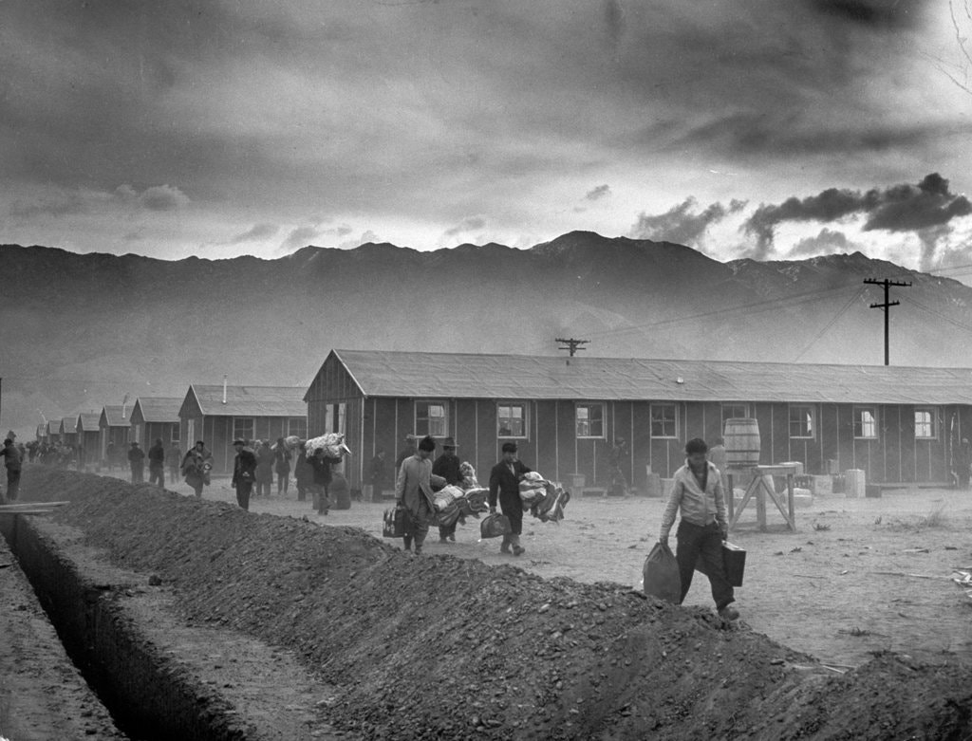
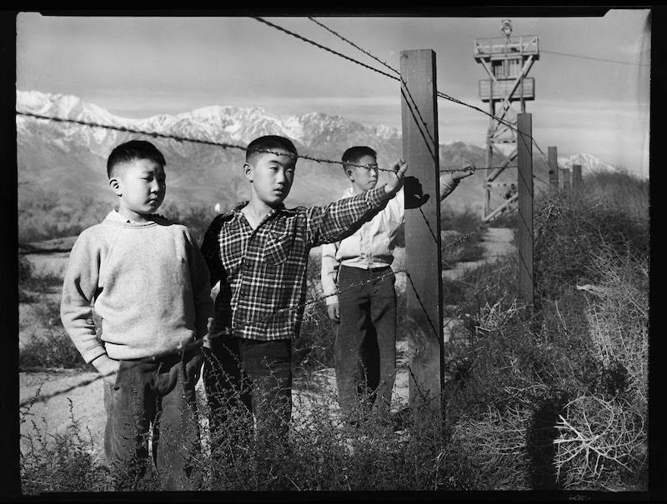
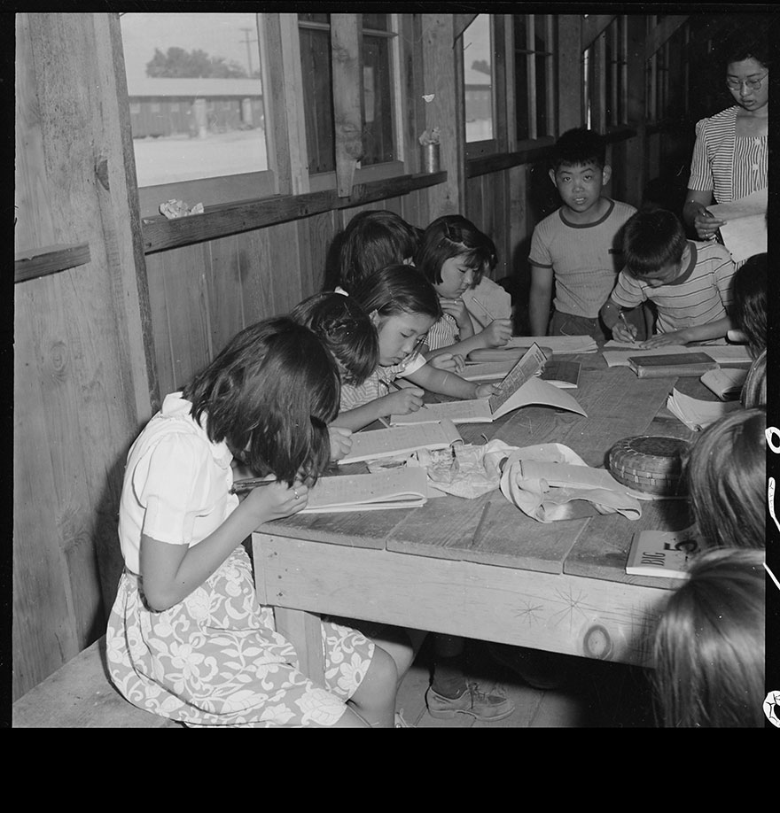
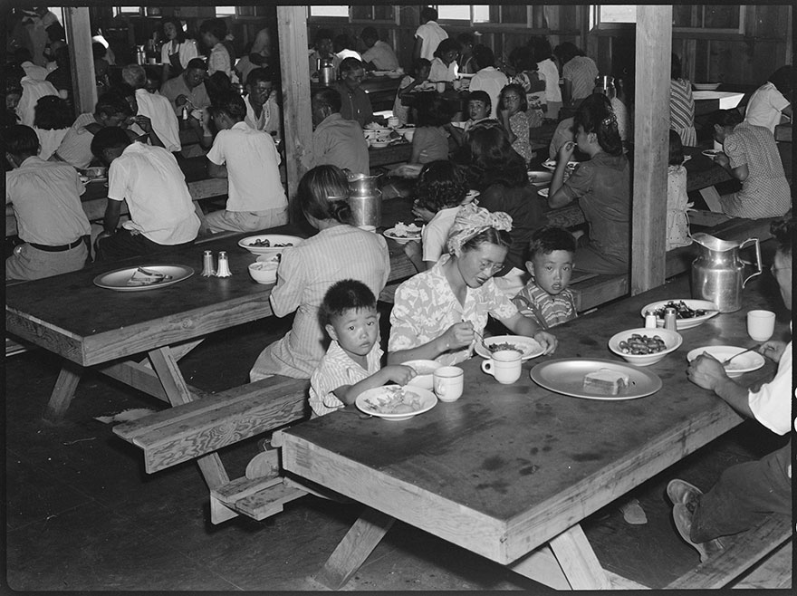
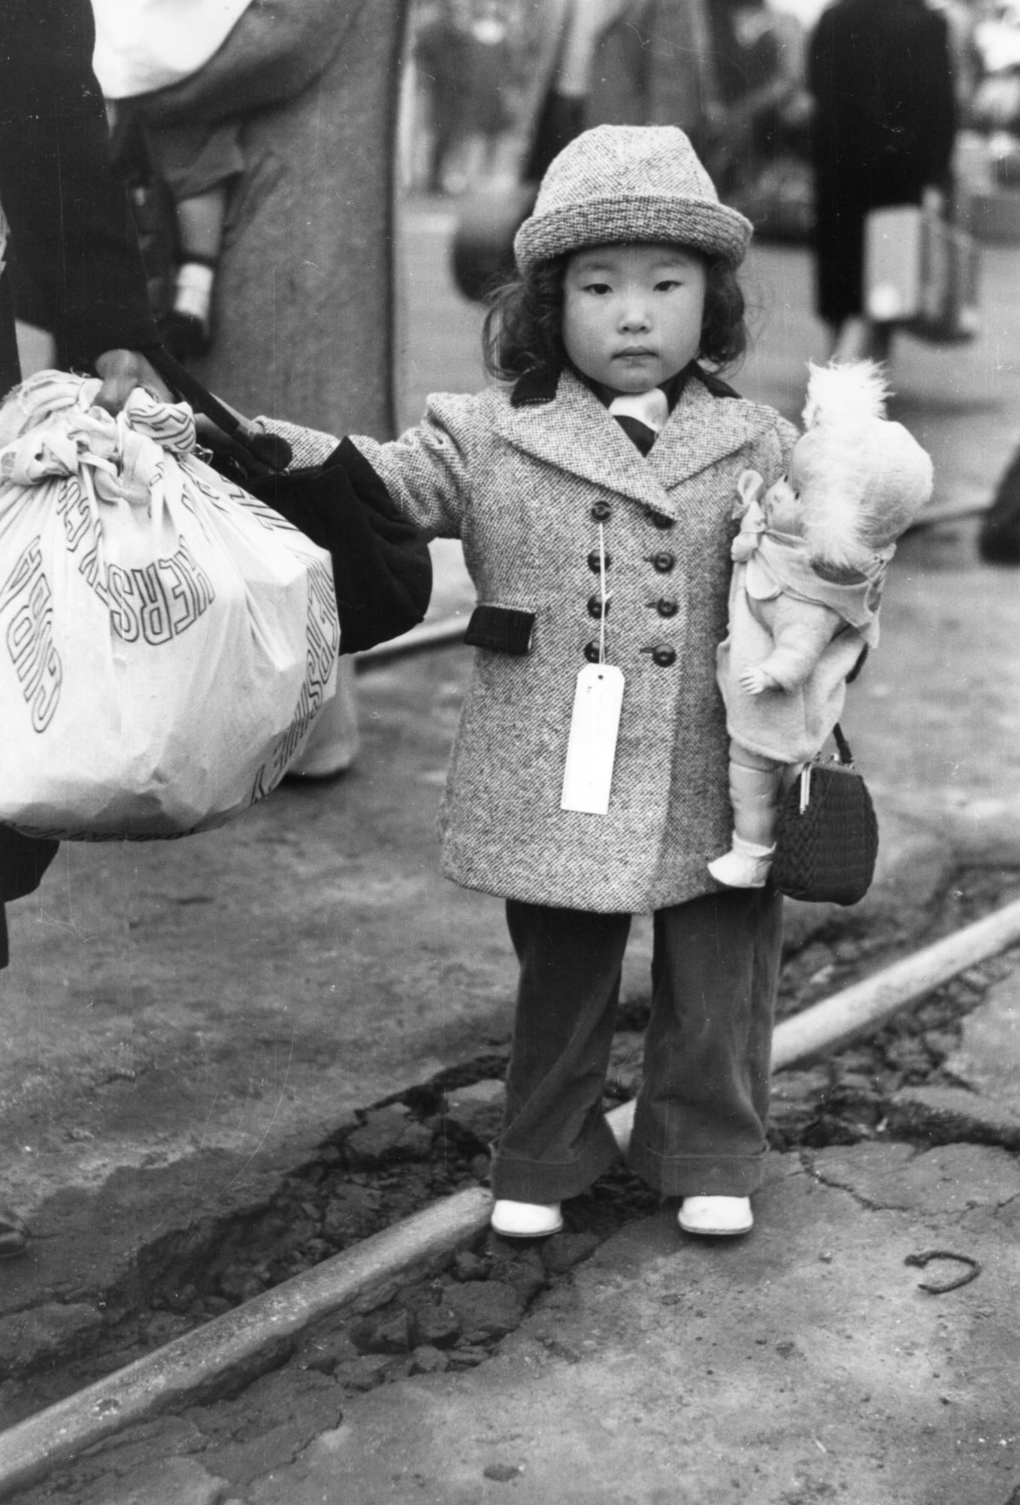
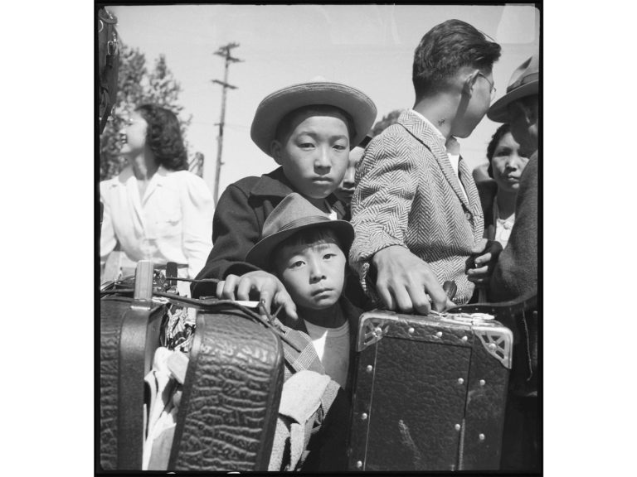
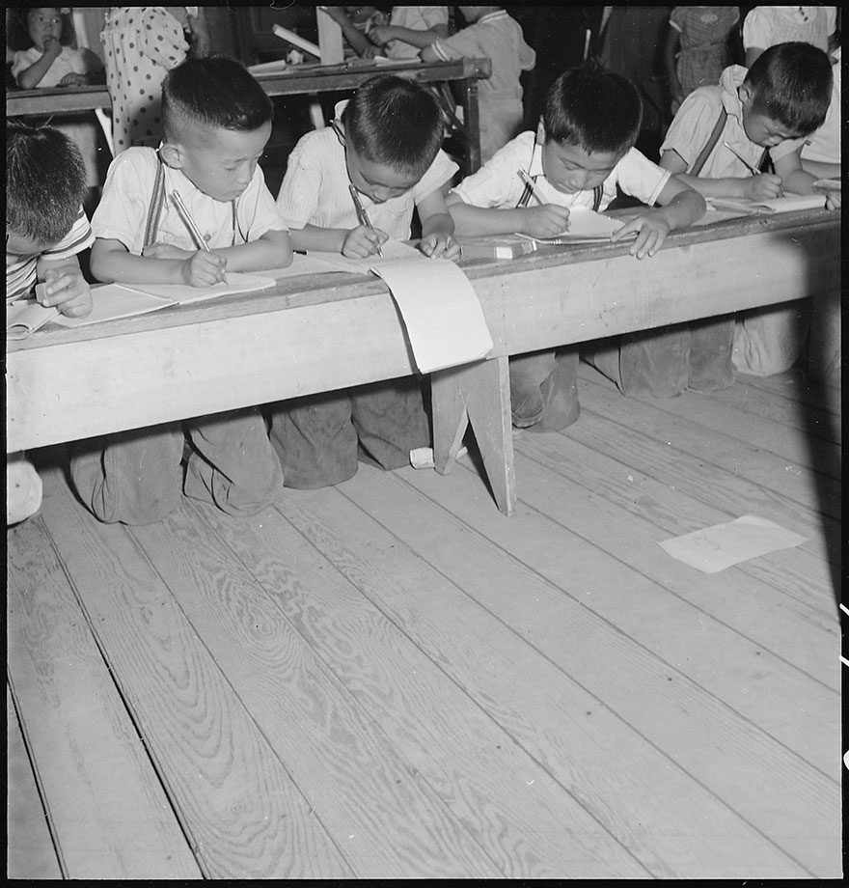
1 & 2) Look at how small the suitcases and bundles are. Imagine packing up everything you own into something so small.
3) Imagine arriving here after two or three days of travel. How does this environment make you feel?
4) Imagine eating every meal in a room like this. What does it sound like? Smell like? Is this a comfortable place to eat?
5 & 6) How do these pictures of school compare to your school?
1
2
3
4
5
6
7
7) How do you think these boys are feeling? How would you feel? Why?

